Name:___________________________________________ Date: _______________________

Calculus: 5-4 HW Fundamental Theorem of Calculus VISCA

In Exercises 1–20, find *dy*/*dx*.

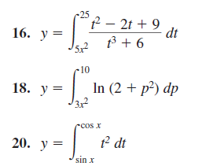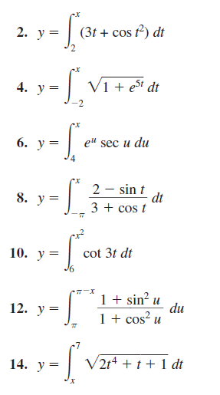

In Exercises 27–40, evaluate each integral using of the Fundamental Theorem.

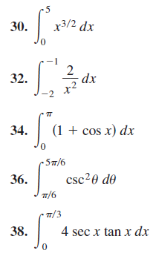

In Exercises 41–44, find the total area of the region between the curve and the *x*-axis.



